Blue Jays A Team R/Up Salisbury Winter League, they were presented with their medals last Wednesday after a fun tournament at

Sarum Academy Salisbury.

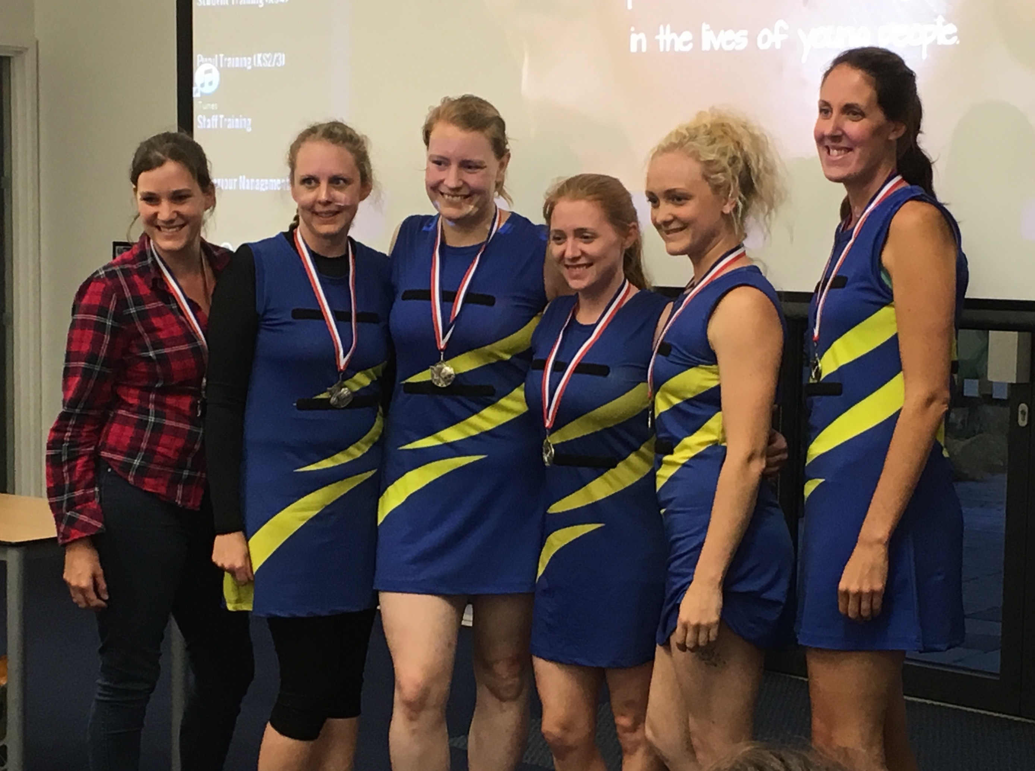 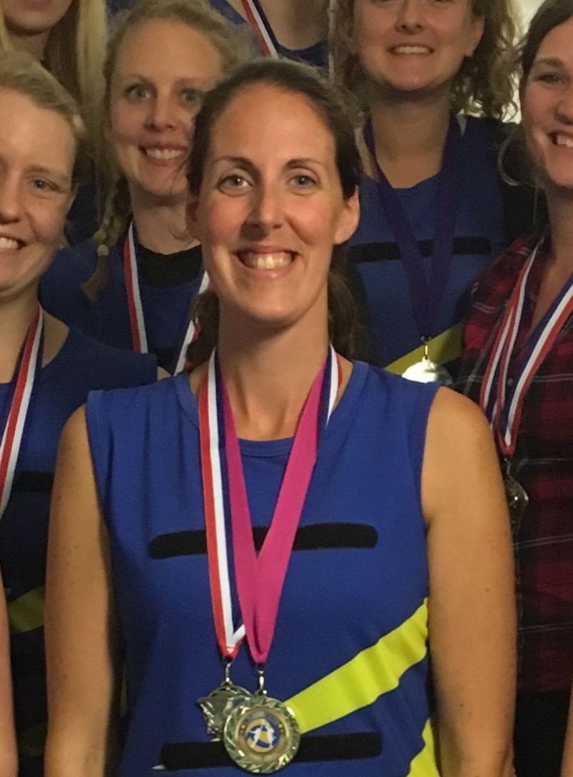 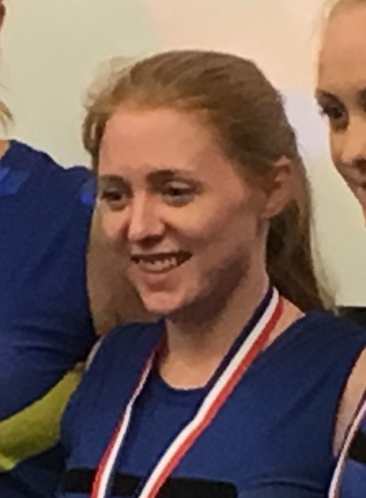

Alice Robson - Umpires Player of the season

Sam Middleton – Players Player of the season

B- Team Winter League

Players Player - Holly Allaway

Umpires Player - Anna J-S

Blue Jays A Team Salisbury Summer League Runners Up

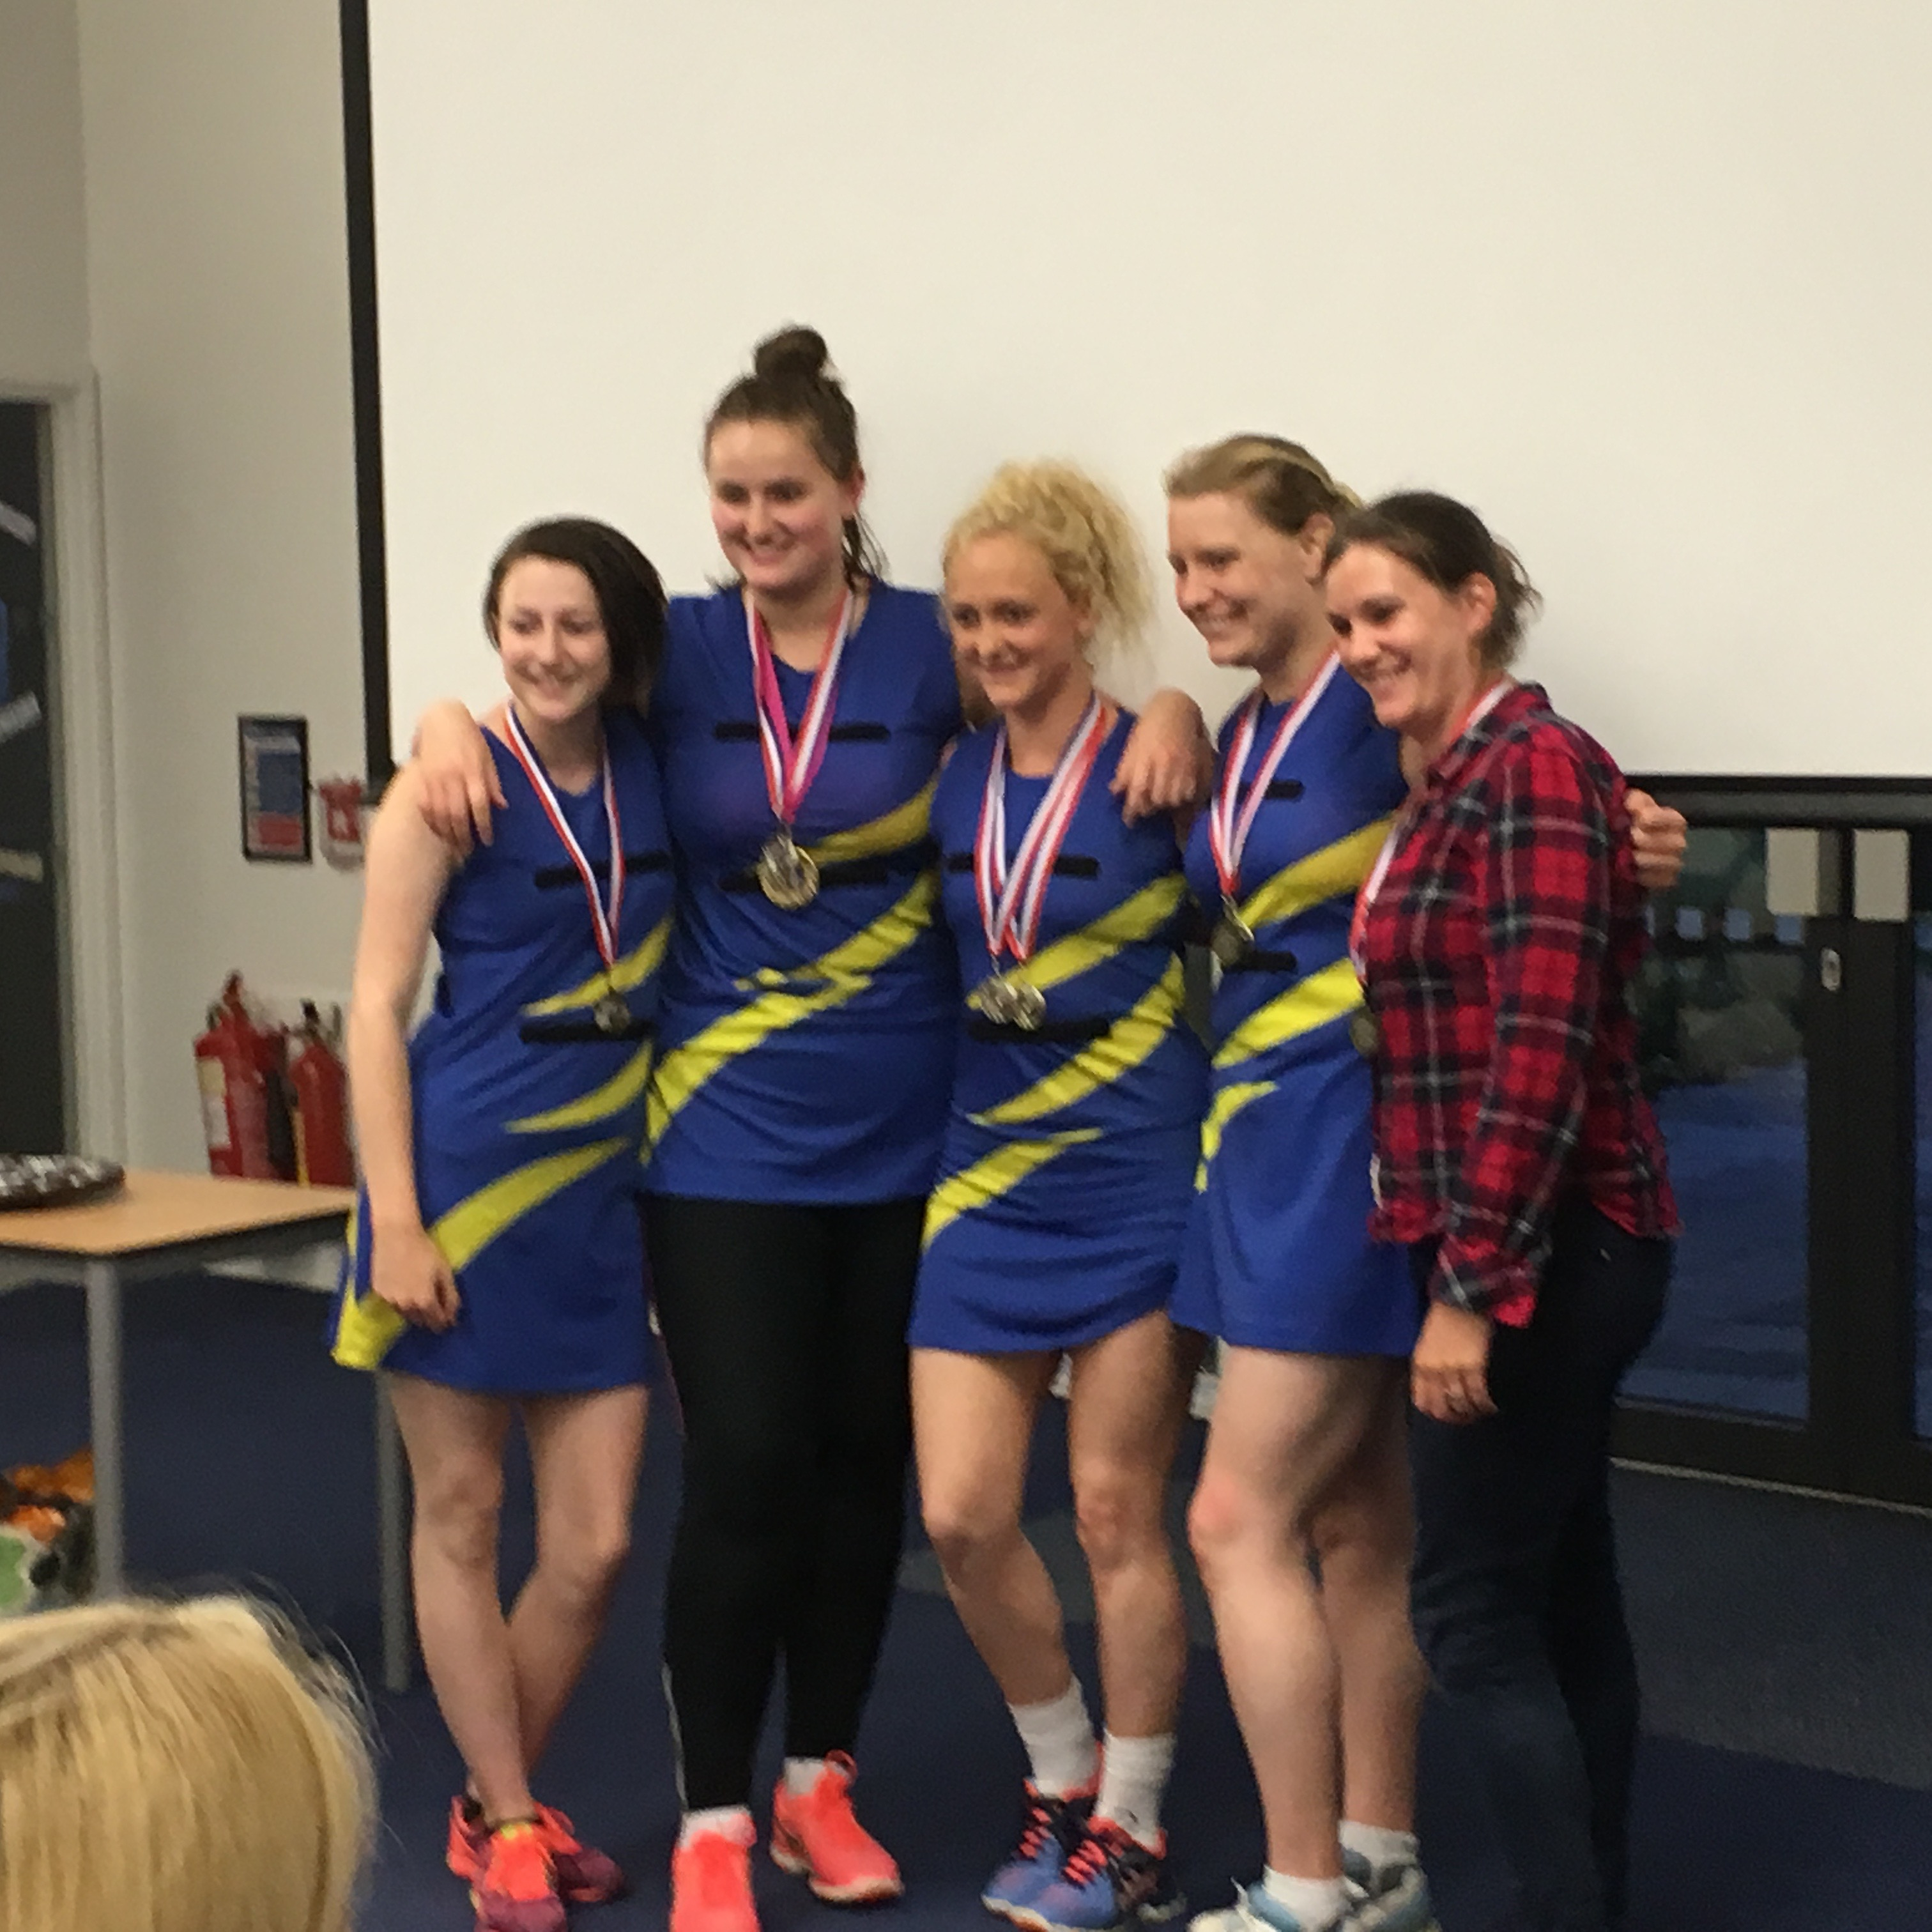

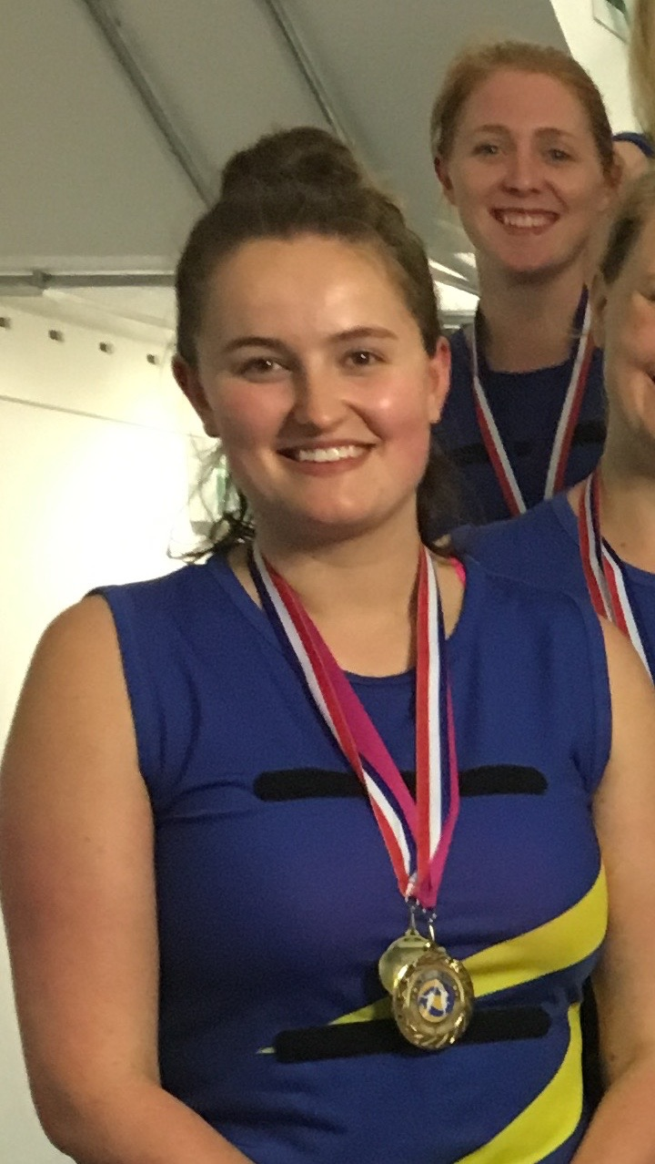

A Team -Elle Hamilton Players Player

Summer League 2017

A Team – Umpires Player

Hannah Peck

B Team – Players Player & Umpires Player

Helen Sarvar

2016-17 Season League Players & Trophy Winners

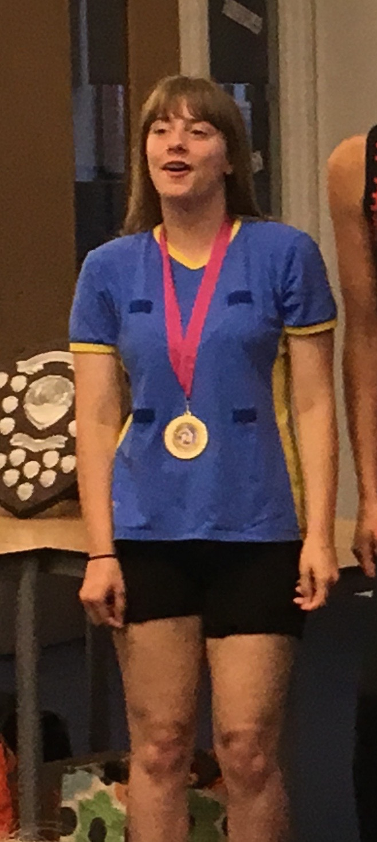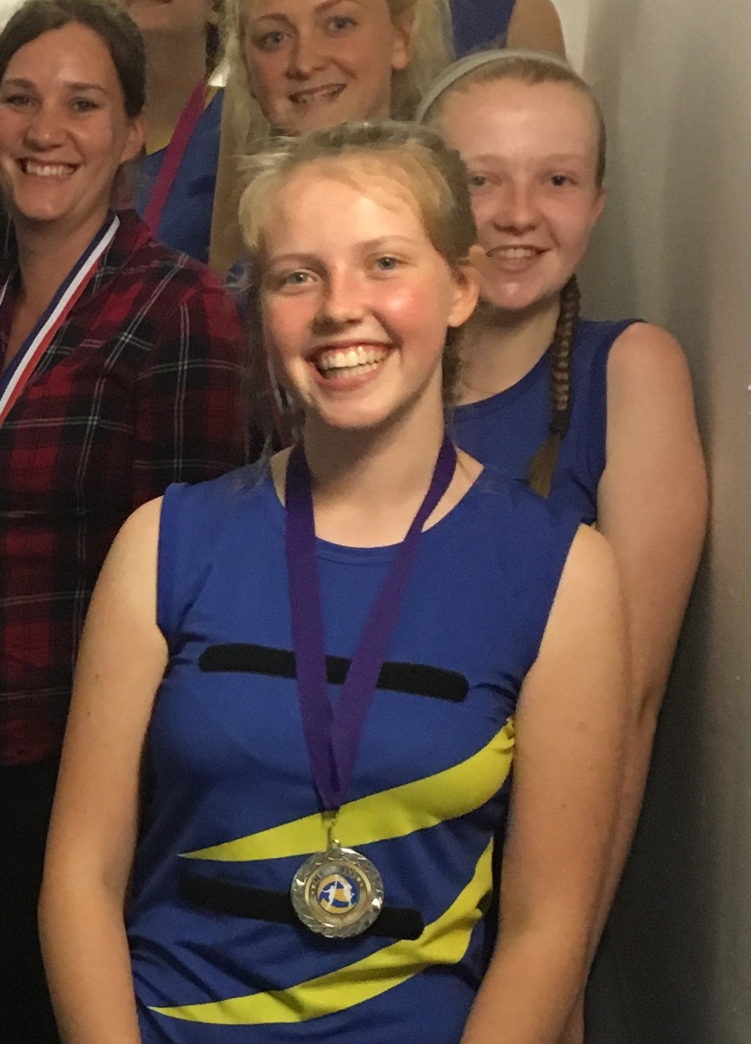

Youth Team Umpires Player Sophie Davidson

Youth Team Players Player Chloe Evens

