Match Report Winter League Wed 26th Jan 2022

B J Youth Team v Swans
What a great game played by the youth team, the shooters were on fire,
converting a lot of distance shots, the first half was Libby and Jemima and
the second Keely and Sherise, both working well together in the circle.
The defence got many turn overs and bought the ball through the court well.
The centre court still needs a little work it is a bit crowded at times and the 2nd phase
does not always work but in general very well played
Players Player – Libby Barret
Coaches Player – Libby Barret.
Won 46 - 32

B J Blue Team v Downton
Started well moving the ball through the court quickly and straight into the shooters.
Beth and Ellie worked well together in the shooting circle and got great long shots.
Sarah & Debbie got many turn overs and complement each other in the circle.
They were up by 6 goals in first break and up by 5 in at half time, and then managed to finish the match with a 7-goal different. Well done.
Players Player Debbie Jackson
Won 35 – 28

Match Report Winter League 2nd Feb 2022

Blue Jays Blue v Downton Jades
Great flowing game, good movement by all players, Hannah played especially well linking the defence and attack beautifully. Amy and Liv worked well together in defence and got many interceptions and turn overs.
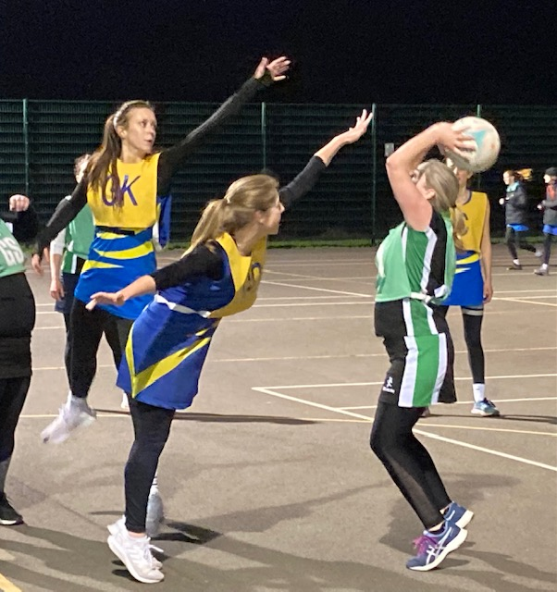
Won 35 - 35
Players Player – Hannah Thomas
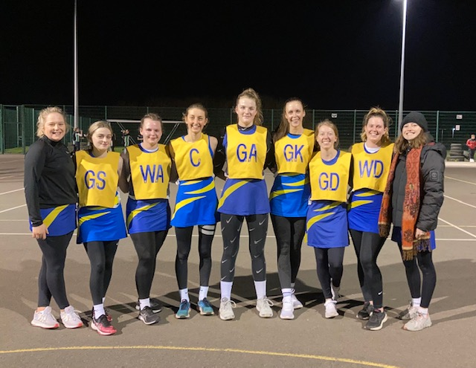

Blue Jays Yellow v Swans
Won 42-38
Players Player - Hannah

