Salisbury Winter League
Match Report 16th Jan 2019
Blue Jays U16 v Blue Jays 2nd team

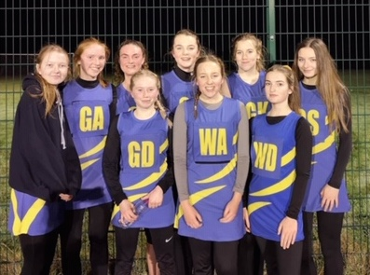

Although the weather was not in anyone’s favour, every single lady in the 2nd team played exceptionally well. Each team has definitely got some things to improve on in the coming weeks and personal targets have been set for some.
An all-round fabulous and friendly match between the club, with an overall score of 23-40. Great win for the ladies 2nd team! Well done all!

Players Player – Ellie Ringwood
Coaches Player - Rosie Beer

