Success for our Junior Tournament after a 3-year break

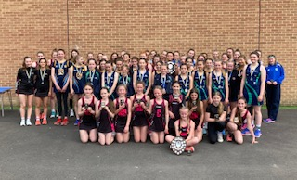
What a fabulous day, 40 teams entered in three age groups, U12,U14 & U16, the standard was very high this year after a 3 year break due to Covid, the weather was glorious, and all our volunteers worked very hard to ensure everyone enjoyed their day.

Winner and R/Ups

Results 2022
U12 Winner – Magic N C R/Ups - Poole N C
U14 Winner – Magic N C R/Ups - Calne
U16 Winner – TTNC Trojans R/Ups - Magic N C

We entered a team in each group but sadly no winners this time, they all had a great day and have gained valuable experience and now know what levels they need to achieve in the coming season.
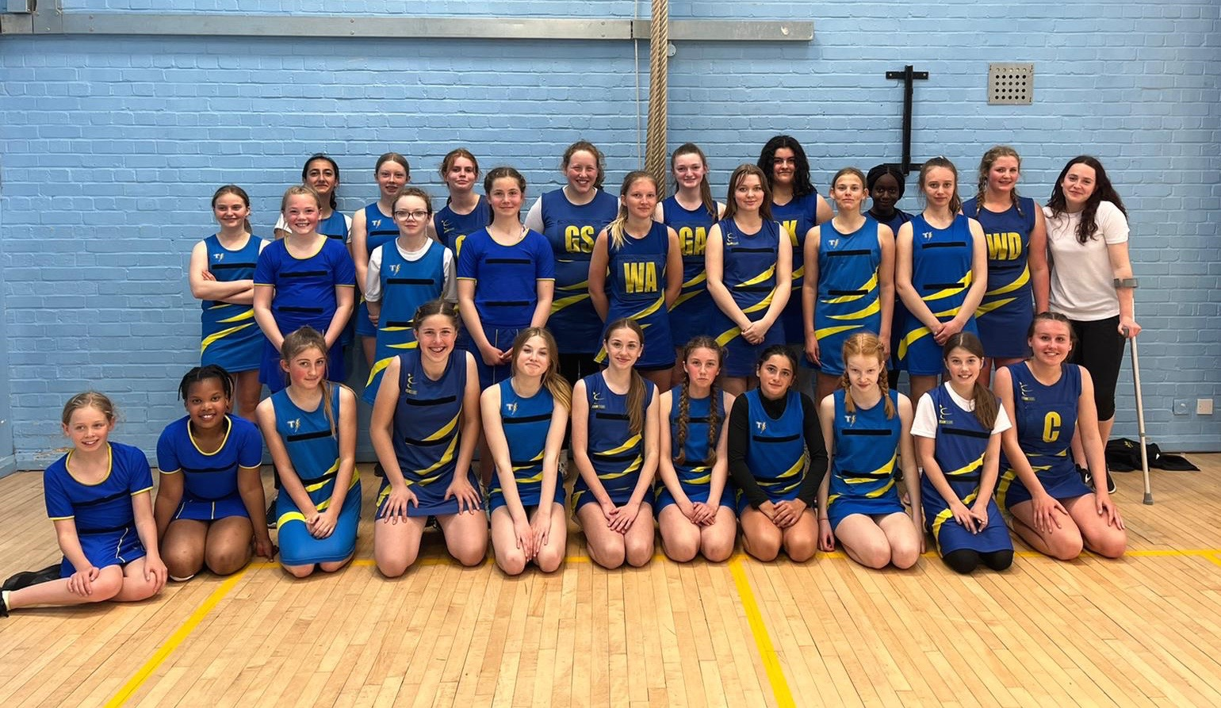

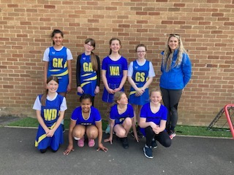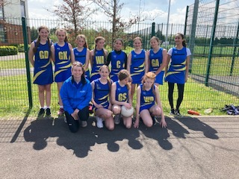
U14’s Team with Coach Ellie
U12’s Team with Coach Sarah
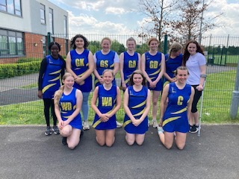
U16’s Team

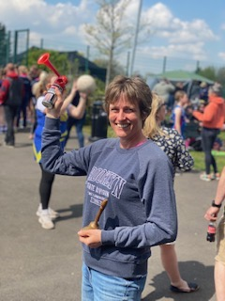
Volunteers
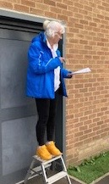
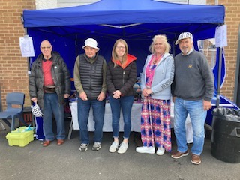
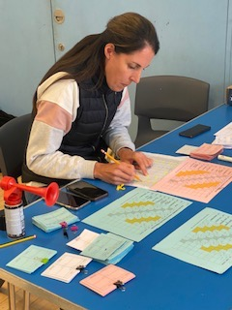

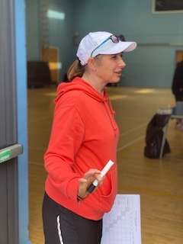
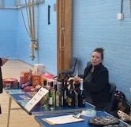
A big, big thank you to all our volunteers, car park attendants, scorers, time keepers, tuck shop organisers, raffle tickets sellers, umpires, coaches, team managers, also thanks for the all donations of cakes and prizes.

