Junior League Match Reports Sunday 5th Dec 2021

Bee’s Match Reports
Blue Jays v Bournemouth lost 2 - 10
A very cold and windy Sunday this week but again the girls played amazingly. First match was against Bournemouth who are a very skilled and talented team. We played very well together good defence from all. Need to keep with our players more next time.
Players Player – Amy
Coaches Player – Harriet
Second match was amazingly well played. Match was against North Dorset. Great shooting from everyone but we need to spread out more.
Players Player – Harriet
Coaches Player – Jenneil

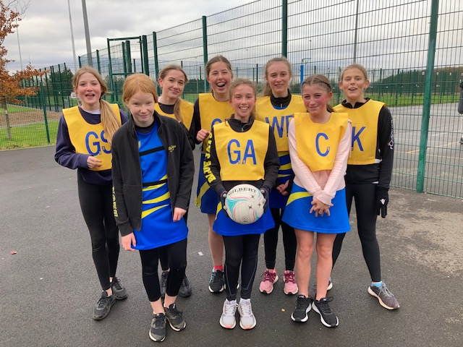
U13’s Match Reports
Blue Jays v Bournemouth won 9 – 0
Players Player – Tilly
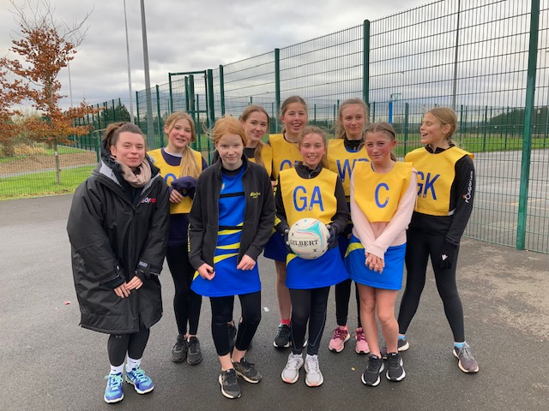

Blue Jays v Hoops won 6 – 4
Players Player – Lottie

U15’s Match Report
Blue Jays v Spires won 19-2
A very cold, blustery Sunday morning saw us play a revised fixture due to other teams withdrawing this week.
Our starting 7 was a different line up again so it was going to be important for all the players to communicate and link up well throughout the court. Tianna returned to Centre and the impact of her in this position was evident from the beginning. She linked up well with Libby to move the ball in to the circle. Lea provided good support at WA and between Libby and Annabel Blue Jays made a strong start leading at half time by 8 goals to 1. The usual defensive unit of Gabby and Maddie ensured lots of interceptions and turnovers and enabled the ball to move swiftly back up court. Dan got plenty of tips and with their first game at GK showed real improvement in awareness of marking their player.
A fast-flowing game where we occasionally overplayed the long ball and misjudged the wind saw Blue Jays finish with a 19-2 win.
Players Player – Libby
Coaches Player – Tianna

