Blue Jays - Kit Descriptions & Price

Dresses are available for U12 +
They come in standard length but if you like it longer this can be arranged at a cost an extra £1 per inch.
Size 6 Chest 30” Length - 30 ½ “
Size 8 Chest 32” Length - 31”
Size 10 Chest 34” Length - 31 ½ ‘
Size 12 Chest 36” Length - 32”
Size 14 Chest 38” Length - 32 ½’
Size 16 Chest 40” Length - 33”
Size 18 Chest 42” Length - 33 ½”
Size 20 Chest 44” Length - 34”
These dresses are tailor made therefore cannot be returned so please make sure you measure yourself carefully, from the shoulder to the hem, we will not be able to exchange them afterwards. Cost from £35.00 to £39.50

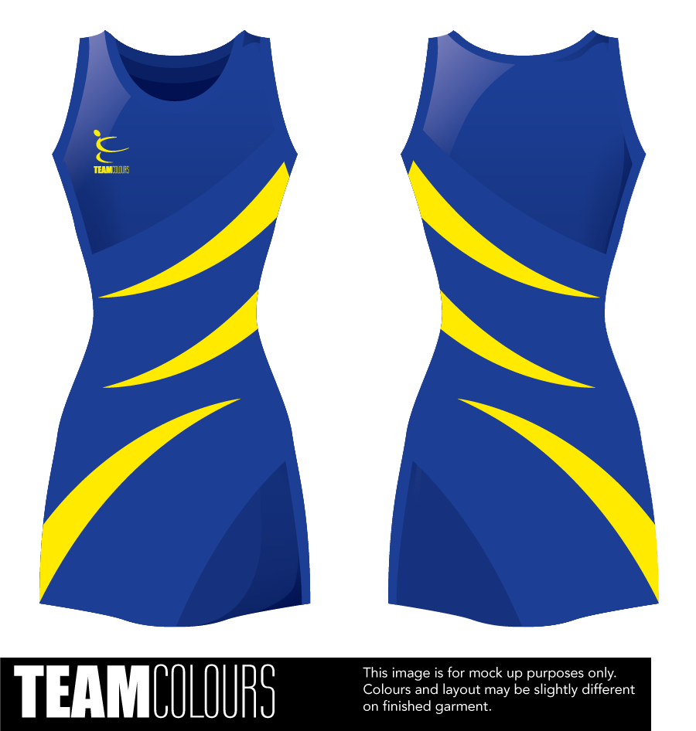

Training Tops – Cost from £4.50 to £7.50
Junior Sizes Chest Size
Age 7-8 30”
Age 9-11 32”
Age 12-13 34”

Adults Sizes Size
X Small 8 30”
Small 10 32”
Medium 12 34”
Large 14 36”
X Large 16 38”
XX Large 18 40”

Small, Medium, Large. X Large & XX Large

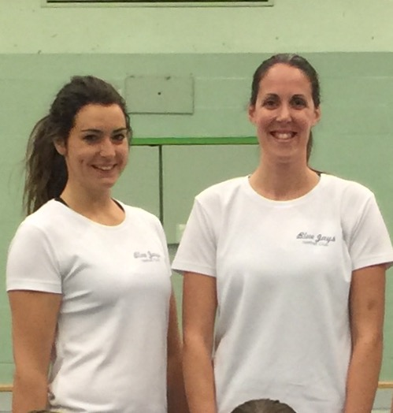

Zipped Sweat Tops from £16.00 to £18.50
Juniors Sizes Chest Size
Age 7-8 30”
Age 9-11 32”
Age 12-13 34
Adults Sizes Size
X Small 8 30”
Small 10 32”
Med 12 34”
Large 14 36”
X Large 16 38”
XX Large 18 40”
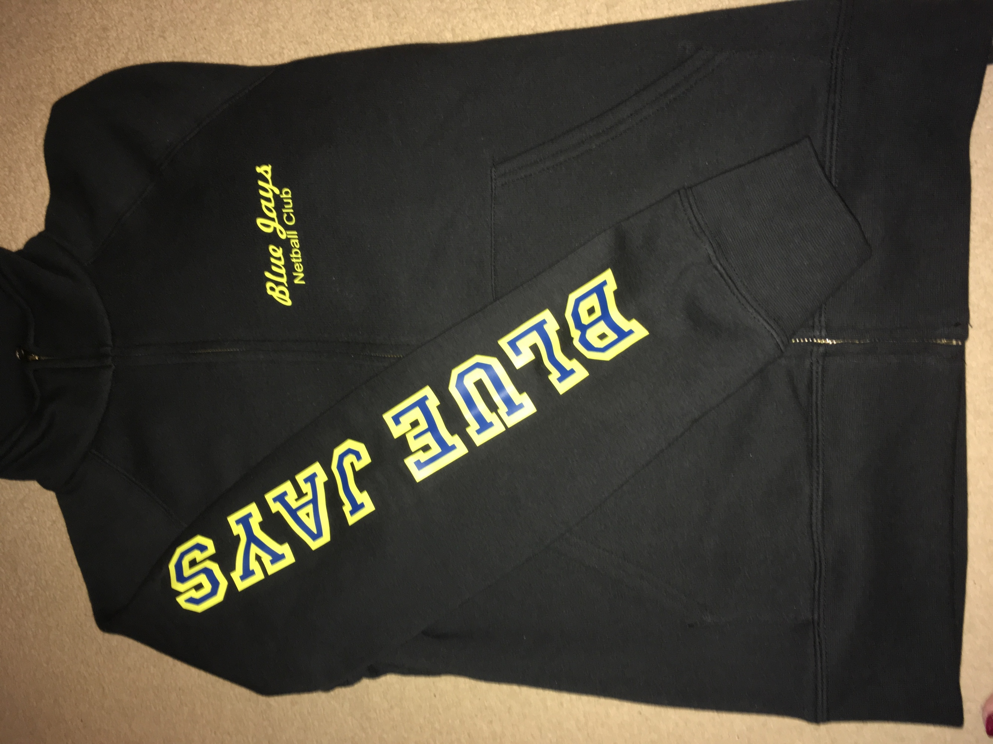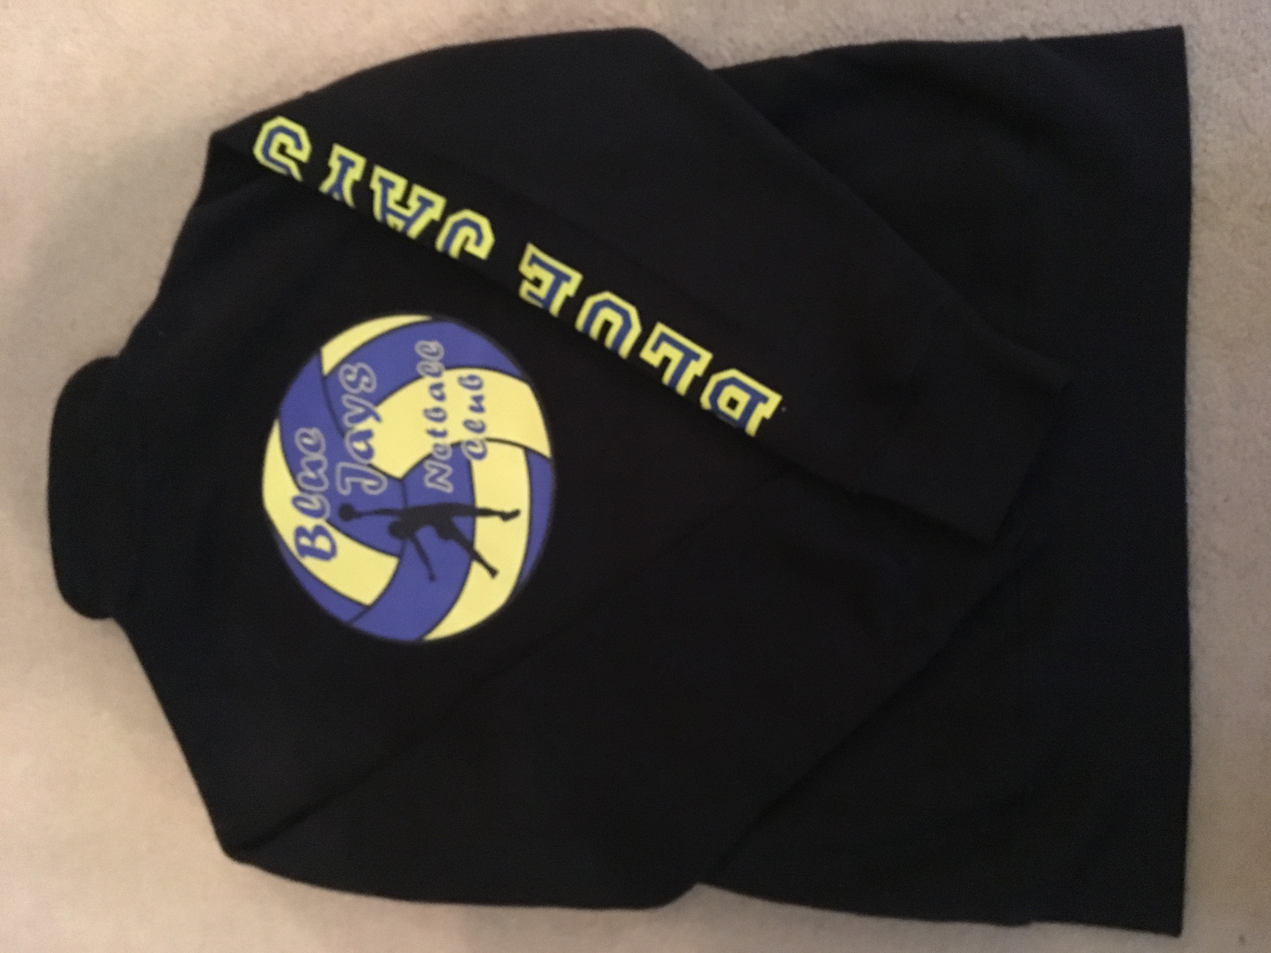
Back
Front

Please return your order form on club night with payment in full, cheques made payable to Blue Jays Netball Club, thank you.

