Junior League Match Reports

Bee’s Results 17th Oct 2021
Blue Jays V Dorset All Stars won 5-1
Players Plater – Natalie
Blue Jays v Calne lost 1-6
Players Player - Harriet

Bee’s Match Report 7th Nov 2021
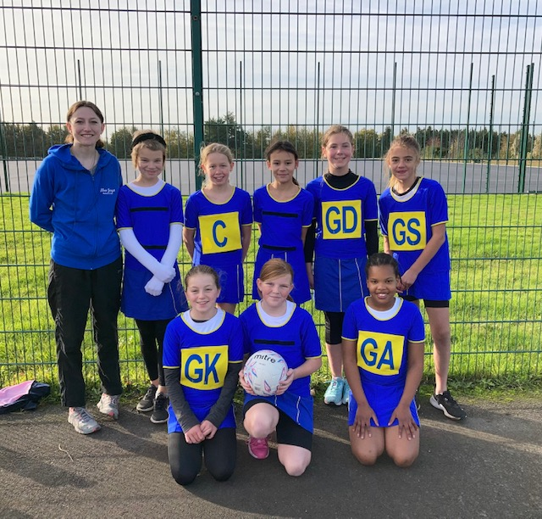
An amazing Sunday for Blue jays u11 team with two wins. Played spires first and won 10-1 everyone played so well and our shooting is really improving. The girls worked so well together as a team. Players player for the first match was Alice and coaches player was Jenniel. Second match was against North Dorset and we won again 11-4. They all played amazing but most of all the managed to intercept so many balls and turn over the game very well. Player's player was Jenniel and coaches player was Lily. Well done to everyone that played Sunday.

U13’s Results 17th Oct 2021
Blue Jays V Dorset All Stars lost 4-6
Players Player – Lottie
Blue Jays v Hoops lost 5-7
Players Player – Lottie

U13’s Results 7th Nov 2021
Blue Jays v Spires U12’s drawn 4-4
Players Player – Izzy
Blue Jays v North Dorset Lost 1-5
Players Player - Bronte

U15’s Match Report 17th Oct 2021
Well done to the girls today. Not the best start when we only had 5 turn up! However, thanks to the 3 girls from the younger group we were able to hold our own in both games.
Score v spires 9-0
Score v hoops 9-4
Lots of positive play and some things to work on. The most important thing is that they connected as a team and were really supportive of each other. Well done everyone and thanks to the parents for your support.
Viki Sent from my iPhone

U15’s Match Report 7th Nov 2021
Today we had to play some players in positions where they don’t normally play - well done to those for giving it a go.
In the first game we struggled mid court to get the ball in to the circle and often gave away loose passes.
The second game was much closer with the defensive circle working hard with lots of tips and turnovers.
We will now need to work on centre passes and creating space to be able to receive the ball. Heads up for next time.

