Blue Jays Netball Club 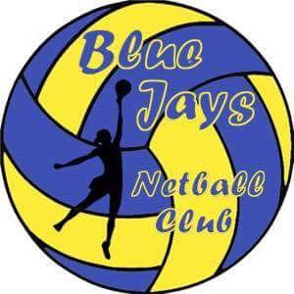

Trip to see Team Bath in action against Northumbria on Friday 24th Match 2017

V

Ticket Price: Juniors Under 16 £8.00 Adults & Over 16 - £12.00

Venue: Bath University Transport: not provided, suggest car share

Time: Doors open at 6.45p Warm-up’s: 7pm Match Start Time: 7.45pm

Tickets on first come, first served basis, please complete the form below and return by
Tuesday 28th February with the ticket fee.

Blue Jays trip to Team Bath V Northumbria Friday 24th March 2017

Name: Age Group:

Telephone Number: Email:

Parents signature if under 18:

Members signature:

No. of tickets Junior @ £8: No. of tickets Adult @ £12:

Total Cost Enclosed: (cheques make payable to Blue Jays Netball Club)

