**Spires Junior League 2018-19 - Blue Jays Report**

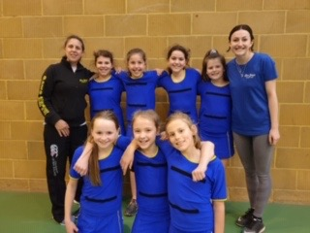

Blue Jays entered a team in each group and enjoyed a good season.

High Five, Yellow Team 8th, Blue Team 10th

U12 - 3rd

U14 - 5th

U16 - 2nd

High Fives with Coaches Clare & Beth

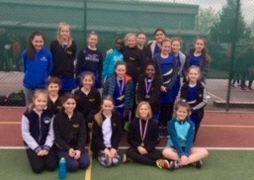

The Players Player for the league were:

High Five – Isabel

U12 – Gabby

U14 – Sherise

U16 – Sophie

Winners received a medal, Well Done

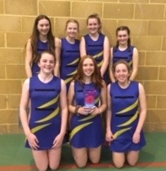

The league finished with a Tournament on Sunday 31st March our numbers were a bit short due to it being Mother’s Day, but all the teams had a great morning of netball and everyone playing well.

High Five – 3rd

U12 – 2nd

U14 – 3rd

U16 – 2nd

U16’s

Well Done all players and we look forward to higher results next season.

Thanks to Spire Reds for all their hard work throughout the season.